Test Case: tc006_SPX_Dev5_Crear_Requisicion_Spot_Tipo_Cobro_Proyect_Urgent
Step 1 - Enter username and password and click to button Enter: Credentials Entered
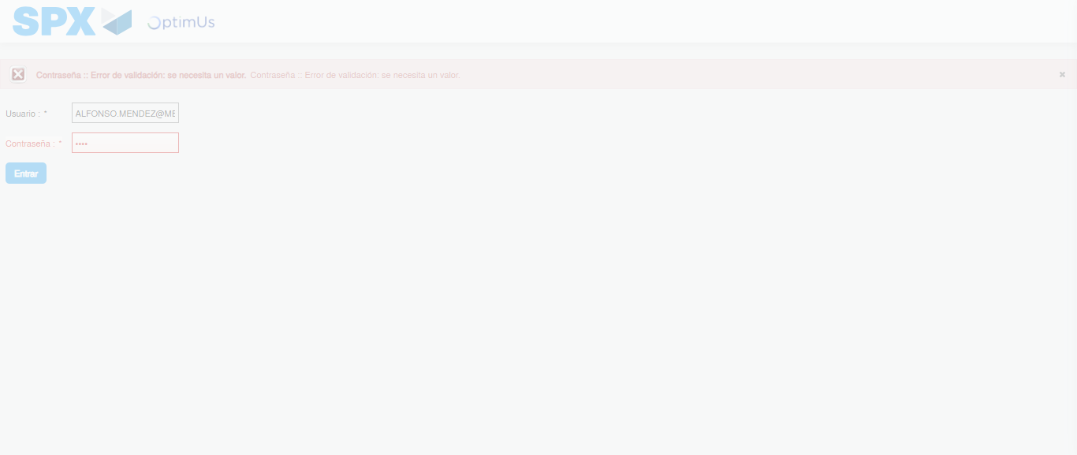Image file-name: QC_Testing-tc006_SPX_Dev5_Crear_Requisicion_Spot_Tipo_Cobro_Proyect_Urgent-1783374657511

Step 2 - Select to UEN and Access to Spot Buy Requisitions : UEN Correctly selected and Correct access
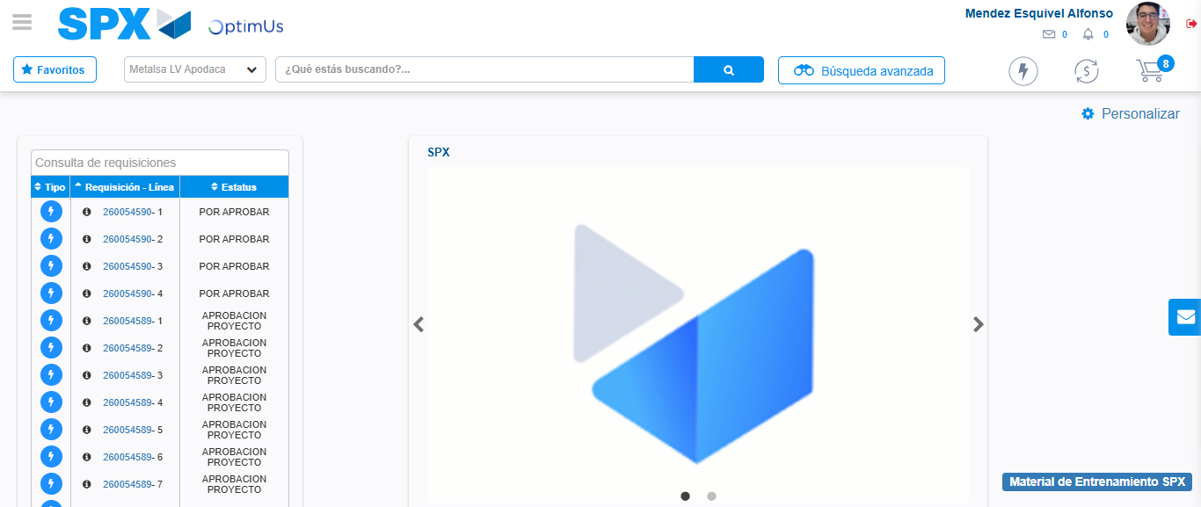Image file-name: QC_Testing-tc006_SPX_Dev5_Crear_Requisicion_Spot_Tipo_Cobro_Proyect_Urgent-1783374683097

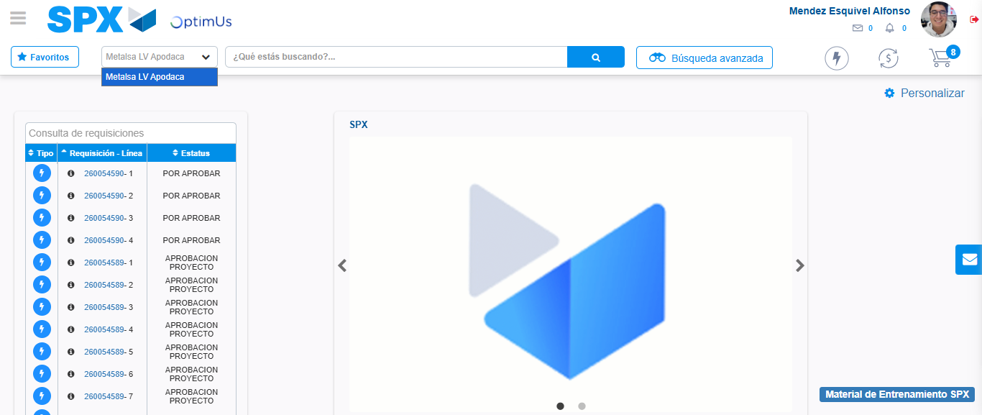Image file-name: QC_Testing-tc006_SPX_Dev5_Crear_Requisicion_Spot_Tipo_Cobro_Proyect_Urgent-1783374685644

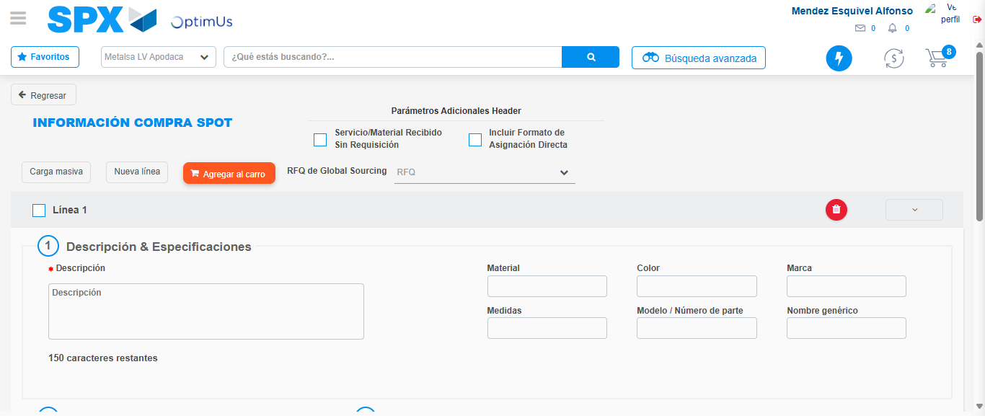Image file-name: QC_Testing-tc006_SPX_Dev5_Crear_Requisicion_Spot_Tipo_Cobro_Proyect_Urgent-1783374707638

Step 3 - Data Capture Spot Buy Requisition: Data captured correctly
Image file-name: QC_Testing-tc006_SPX_Dev5_Crear_Requisicion_Spot_Tipo_Cobro_Proyect_Urgent-1783374707876

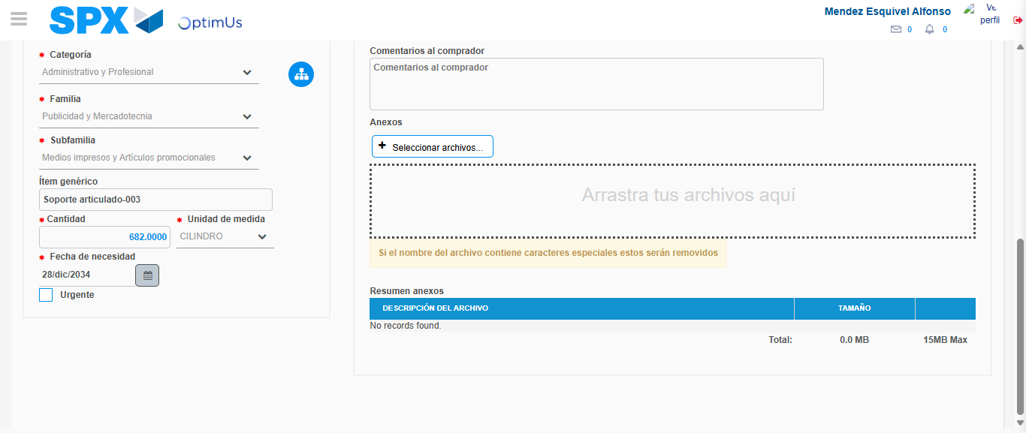Image file-name: QC_Testing-tc006_SPX_Dev5_Crear_Requisicion_Spot_Tipo_Cobro_Proyect_Urgent-1783374718125

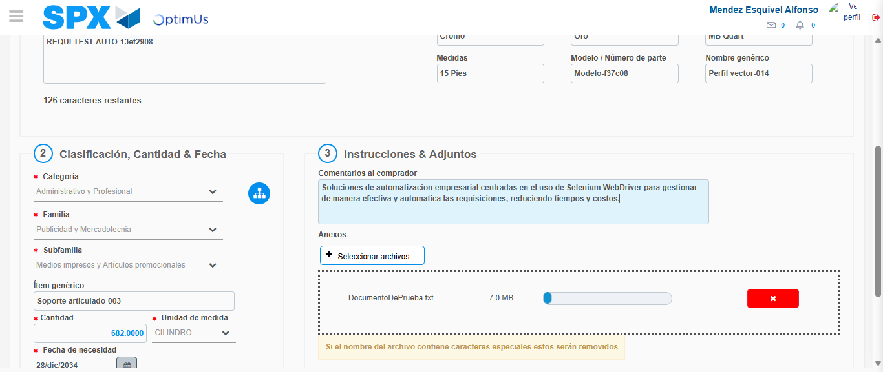Image file-name: QC_Testing-tc006_SPX_Dev5_Crear_Requisicion_Spot_Tipo_Cobro_Proyect_Urgent-1783374718853

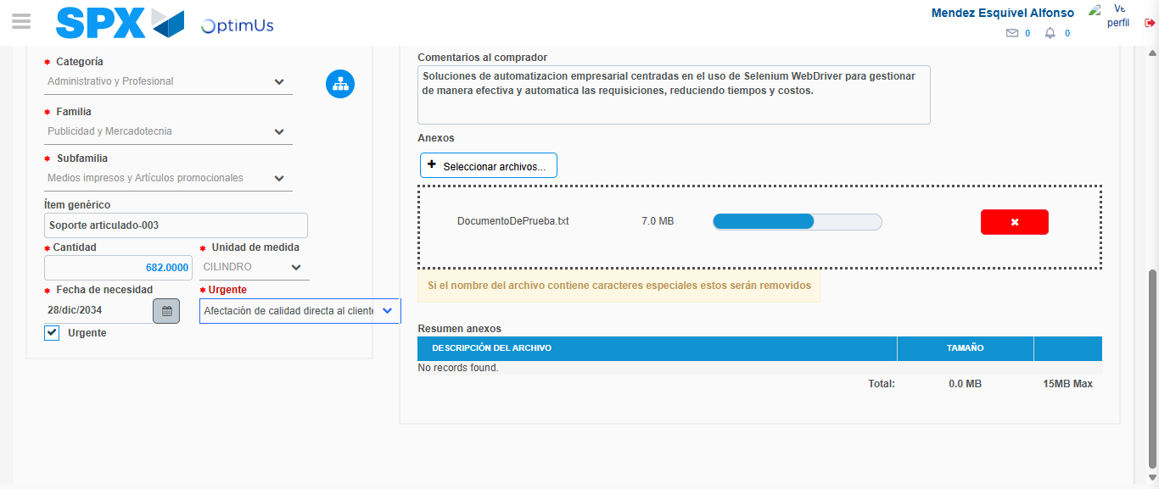Image file-name: QC_Testing-tc006_SPX_Dev5_Crear_Requisicion_Spot_Tipo_Cobro_Proyect_Urgent-1783374722512

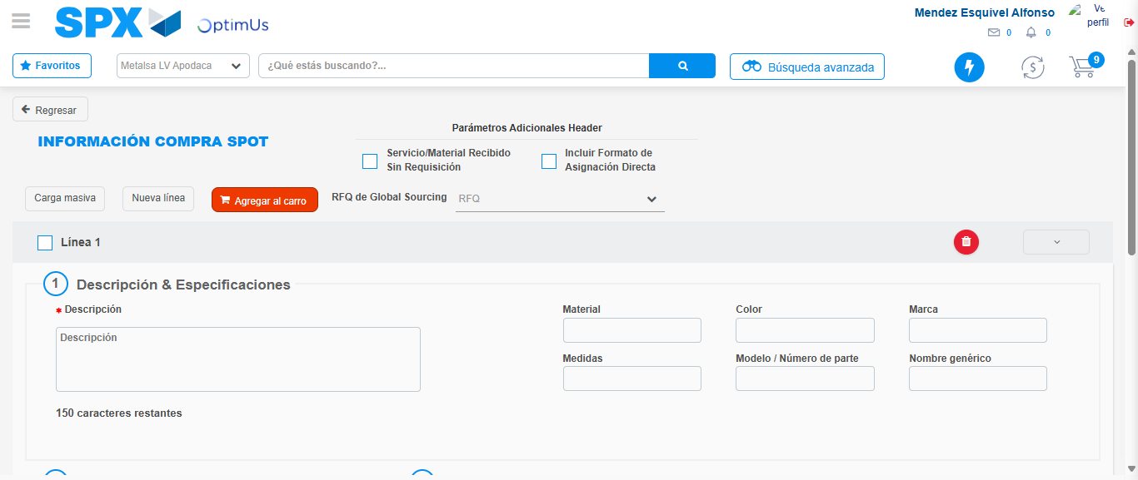Image file-name: QC_Testing-tc006_SPX_Dev5_Crear_Requisicion_Spot_Tipo_Cobro_Proyect_Urgent-1783374729389

Step 7 - Return to Main Page SPX : Return to Main Page SPX
Image file-name: QC_Testing-tc006_SPX_Dev5_Crear_Requisicion_Spot_Tipo_Cobro_Proyect_Urgent-1783374683097

Image file-name: QC_Testing-tc006_SPX_Dev5_Crear_Requisicion_Spot_Tipo_Cobro_Proyect_Urgent-1783374685644

Image file-name: QC_Testing-tc006_SPX_Dev5_Crear_Requisicion_Spot_Tipo_Cobro_Proyect_Urgent-1783374707638

Image file-name: QC_Testing-tc006_SPX_Dev5_Crear_Requisicion_Spot_Tipo_Cobro_Proyect_Urgent-1783374731692

Image file-name: QC_Testing-tc006_SPX_Dev5_Crear_Requisicion_Spot_Tipo_Cobro_Proyect_Urgent-1783374731845

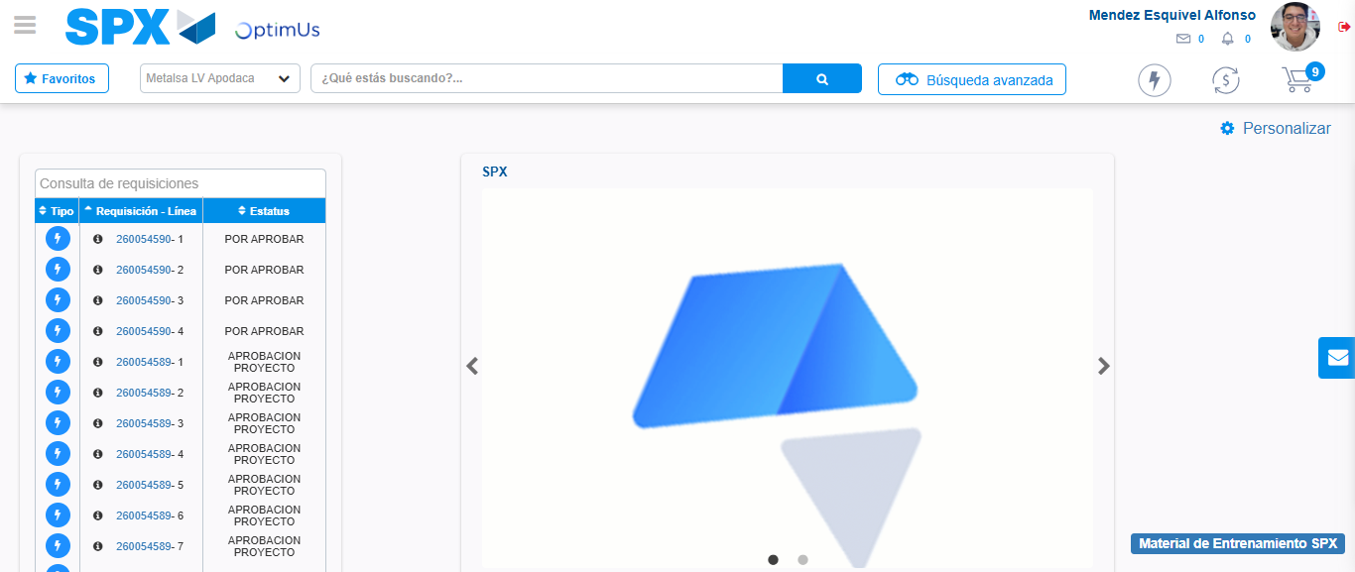Image file-name: QC_Testing-tc006_SPX_Dev5_Crear_Requisicion_Spot_Tipo_Cobro_Proyect_Urgent-1783374752874

Step 8 - Log Out : Log Out SPX
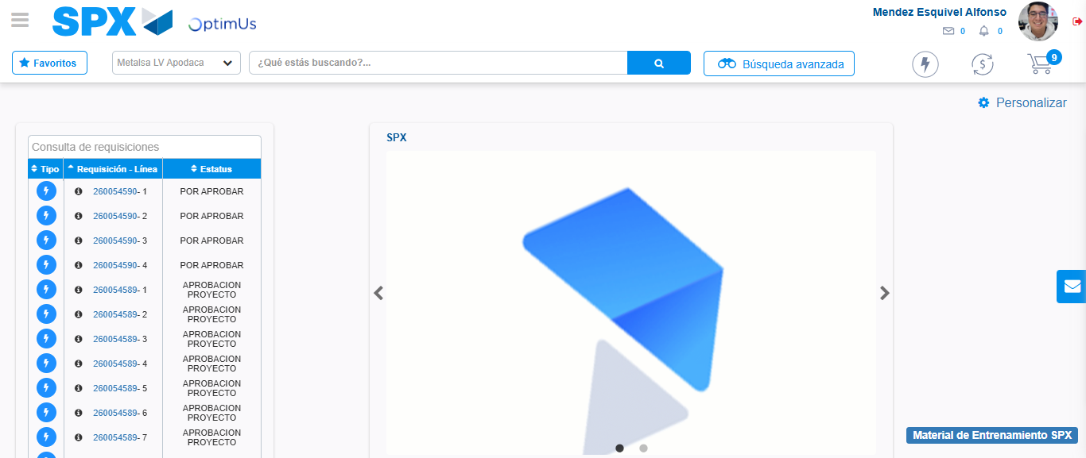Image file-name: QC_Testing-tc006_SPX_Dev5_Crear_Requisicion_Spot_Tipo_Cobro_Proyect_Urgent-1783374753136

